DENTAL LABORATORIES BUSINESS PLAN

Executive Summary
Wright's Dental Laboratory is being established with the goal of providing dentists with restorations of superior quality and value. We offer all the state-of-the-art esthetic materials. Our product quality and services are excellent.

At Wright's Dental Laboratory, we recognize that every practice is different... and every doctor is unique. We will take the time to listen to casework problems. Examine the doctor's individual situation. In short, we reach a full understanding of their needs before we recommend a solution. Then, working as their partner, we put our extensive resources to work for them.

The result is creative and practical solutions to their casework needs on a consistent basis. All backed by over twenty-five years of experience and an investment in the techniques that enhance patient care quality like Product C*, Brand B, Brand B Model 2, and Product E, as well as all the premier implant systems. At Wright's Dental Laboratory, our products and services are a valuable complement to well-established restorative treatment plans that promote aesthetics, tooth reinforcement and conservative preparation techniques.

*Registered Trademark brand and product names have been disguised throughout this sample plan.

Keys to Success
The keys to success for Wright's Dental Laboratory are:

Our dental laboratory must continually adjust its methods to meet the constantly evolving challenges of dentistry and aspirations of the dental professional.
Our dental laboratory must be deeply and loyally committed to maintaining CONSISTENT product excellence.
Our dental laboratory's only dynamic resource is people. It must develop opportunities for each person to use his/her abilities to the utmost of their potential.
Objectives
The objectives of Wright's Dental Laboratory are as follows:

Increase sales significantly each year.
Increase the number of dentists using lab services aggressively each year.
Expand service area to include the entire LochJaw tri-county area.

Need actual charts?
We recommend using Business Plan Pro as the easiest way to create graphs for your own business plan.

Edit this sample plan »
Page 1 2 3 4 5 6 7 8 « Previous Page Next Page »

Read more: http://www.bplans.com/dental_laboratories_business_plan/executive_summary_fc.php#ixzz1RnKEWiJP

Company Summary
Wright's Dental Laboratory offers state-of-the-art dental restorations services to dental professionals.

Charles Wright attended State University and is a certified dental technician. He entered the dental laboratory industry in 1994 and by 2000 he had established his own small dental laboratory. Charles now joins his expertise with that of his brother, David, to create Wright's Dental Laboratory. The synergy of their respective talents will allow the precision restorative capabilities of Wright's Dental Laboratory to consistently provide leading-edge technologies and a high index of progressive services to the profession in the greater LochJaw area.

As an advocate of continuing dental education, Mr. Wright's commitment to continuing education is illustrated by his involvement with metal-free restorations. Charles has successfully completed training in such state of the art techniques as Product E and Product E model 2 and Brand B model 2. He has also completed training for all the premier implant systems including Brand J, Brand K, Product L, Product M, Brand N, and Brand O.

Among his accomplishments, Charles has held the posts of vice president, secretary and treasurer of the Oregon State Dental Laboratory Association. Additionally, he is a member of the National Association of Dental Laboratories (NADL), the State Dental Laboratory Association and the American Academy of Cosmetic Dentistry (AACD).

David Wright attended State University and is a certified dental technician. He has spent over ten years working with some of the region's most respected practitioners. David is committed to continuing education and has successfully completed Corporation X's Advanced Crown & Bridge Dental Studies. He has also successfully completed training in all the premier implant systems including Brand J, Brand K, Product L, Product M, Brand N and Brand O.

David entered the dental laboratory industry in 1991. He began his training under the tutelage of his father with various phases of fixed and removable techniques. Over the years, David completed his training to become fully proficient in the design and fabrication of precision attachment restorations, implants and full mouth rehabilitation cases.

Start-up Summary
The start-up cost of Wright's Dental Laboratory will consist primarily of equipment. Charles and David will each invest personal funds and also secure a long-term loan.

Need actual charts?
We recommend using Business Plan Pro as the easiest way to create graphs for your own business plan.

Edit this sample plan »

Start-up Requirements
Start-up Expenses
Legal $1,000
Stationery etc. $300
Brochures $1,000
Insurance $2,000
Rent $2,000
Lab Setup $30,000
Office Setup $20,000
Expensed Equipment $20,000
Total Start-up Expenses $76,300
Start-up Assets
Cash Required $71,700
Start-up Inventory $10,000
Other Current Assets $12,000
Long-term Assets $80,000
Total Assets $173,700
Total Requirements $250,000

Need real financials?
We recommend using Business Plan Pro as the easiest way to create automatic financials for your own business plan.

Edit this sample plan »

Company Ownership
Wright's Dental Laboratory, located in a custom designed, 8,000 square foot facility using the latest, state-of-the-art restoration production systems and computerized case tracking, is owned by Charles and David Wright. The company will operate as a general partnership with both Charles and David performing management functions.
Page 1 2 3 4 5 6 7 8

Read more: http://www.bplans.com/dental_laboratories_business_plan/company_summary_fc.php#ixzz1RnKT5gO6

Products
Wright's Dental Laboratory offers the following products:

CROWN AND BRIDGE
Ceramics Brand A Brand B
Porcelain to metal Brand A inlay/onlay Brand B inlay
Porcelain veneers Brand A bond to metal Brand B model 2
Product C
Product D
Product E
Product F
Product F model 2
REMOVABLES
Dentures & Partials Splints/Stents Orthodontics
Full dentures Brand G
Partial dentures Hard splint (night guard)
Night guards Implant stent
Relines Sports guard
Laser welded repairs Surgical template
Soft liners Bleaching fluoride trays
Brand H

Read more: http://www.bplans.com/dental_laboratories_business_plan/products_fc.php#ixzz1RnKfNX00

Market Analysis Summary
The LochJaw tri-county area has over 300 dentists. Next to salaries and benefits for associates, assistants and hygienists, dental laboratory fees are a dentist's greatest expense.
Currently, there are seven dental labs in LochJaw. Of the seven, only four are full service. Most importantly, a new lab has not opened in the LochJaw area in the past six years. Over the past six years, the area's population has grown tremendously. The current labs have not invested in the newest technology. Wright's Dental Laboratory will set a new standard for products and services.
No where is this more important than in the dental care for children and seniors. The new materials and techniques creates more options for dentists to serve their young and senior patients. Wright's Dental Laboratory is investing heavily in these new techniques and materials.

Market Segmentation
Wright's Dental Laboratory will focus on dental professionals who work in the following three areas:
- Dental services for seniors;
- Dental services for children;
- General dental services.

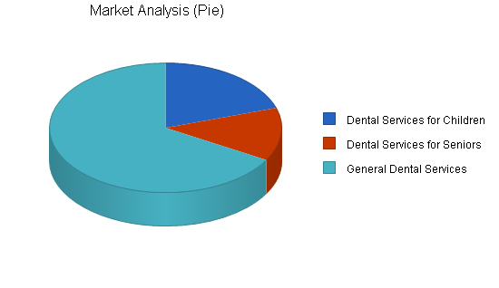

Need actual charts?
We recommend using Business Plan Pro as the easiest way to create graphs for your own business plan.
Edit this sample plan »
Market Analysis
 |  | Year 1 | Year 2 | Year 3 | Year 4 | Year 5
Potential Customers | Growth |  |  |  |  |  | CAGR
Dental Services for Children | 10% | 60 | 66 | 73 | 80 | 88 | 10.05%
Dental Services for Seniors | 15% | 40 | 46 | 53 | 61 | 70 | 15.02%
General Dental Services | 13% | 200 | 226 | 255 | 288 | 325 | 12.91%
Total | 12.64% | 300 | 338 | 381 | 429 | 483 | 12.64%

Need real financials?
We recommend using Business Plan Pro as the easiest way to create automatic financials for your own business plan.
Edit
Read more: http://www.bplans.com/dental_laboratories_business_plan/market_analysis_summary_fc.php#ixzz1RnKwitAG

Strategy and Implementation Summary
Wright's Dental Laboratory will aggressively pursue dental professionals in the LochJaw area by offering discounted services to encourage them to try the new lab. Charles Wright will manage the marketing campaign to promote the business. He has extensive contacts in the dental community that will be critical to the building of the business.

Sales Strategy
The sales strategy will focus on offering dental professionals the new techniques and equipment that will assist them in serving their speciality populations (i.e., children and seniors).

Sales Forecast
For the first month there will be no sales, as the company will be establishing its operations. We anticipate that sales will grow quickly during the second and third month of operation.
The following is the sales forecast for three years.

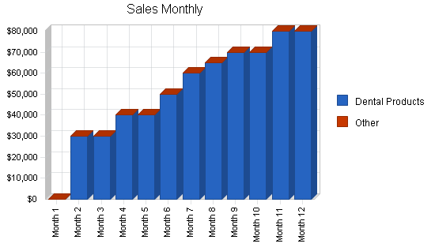

Need actual charts?
We recommend using Business Plan Pro as the easiest way to create graphs for your own business plan.
Edit this sample plan »

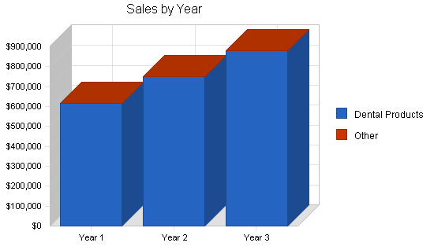

Need actual charts?
We recommend using Business Plan Pro as the easiest way to create graphs for your own business plan.
Edit this sample plan »
Sales Forecast
 | Year 1 | Year 2 | Year 3
Sales
Dental Products | $615,000 | $750,000 | $880,000
Other | $0 | $0 | $0
Total Sales | $615,000 | $750,000 | $880,000
Direct Cost of Sales | Year 1 | Year 2 | Year 3
Dental Products | $221,000 | $269,250 | $315,920
Other | $0 | $0 | $0
Subtotal Direct Cost of Sales | $221,000 | $269,250 | $315,920

Need real financials?
We recommend using Business Plan Pro as the easiest way to create automatic financials for your own business plan.
Edit this sample plan »
Read more: http://www.bplans.com/dental_laboratories_business_plan/strategy_and_implementation_summary_fc.php#ixzz1RnL7uRe7

Management Summary
The management team for Wright's Dental Laboratory will be Charles and David Wright. Charles will be responsible for marketing, sales, customer relations. David will be responsible for managing the dental lab operation.

Personnel Plan
The personnel plan for Wright's Dental Laboratory is as follows:
- Marketing/sales manager
- Lab manager
- Lab techs (4)
- Customer service (1)
Part way through the second year of operation it is estimated that the Lab will have to hire an additional customer service operator.
Personnel Plan
 | Year 1 | Year 2 | Year 3
Marketing/Sales Mgr | $48,000 | $50,000 | $52,000
Lab Mgr | $48,000 | $50,000 | $52,000
4 Lab Techs | $144,000 | $152,000 | $160,000
Customer Service | $24,000 | $38,000 | $60,000
Total People | 7 | 7 | 7
Total Payroll | $264,000 | $290,000 | $324,000

Need real financials?
We recommend using Business Plan Pro as the easiest way to create automatic financials for your own business plan.
Edit this sample plan »
Read more: http://www.bplans.com/dental_laboratories_business_plan/management_summary_fc.php#ixzz1RnLZGVm7

Financial Plan
The following is the financial plan for Wright's Dental Laboratory.

Start-up Funding
Each of the two Wright's, David and Charles, will invest in the venture. An additional long-term loan will be secured from the SBA, or local lenders, with an interest rate not more that 10%.
Start-up Funding
Start-up Expenses to Fund | $76,300
Start-up Assets to Fund | $173,700
Total Funding Required | $250,000
Assets
Non-cash Assets from Start-up | $102,000
Cash Requirements from Start-up | $71,700
Additional Cash Raised | $0
Cash Balance on Starting Date | $71,700
Total Assets | $173,700
Liabilities and Capital
Liabilities
Current Borrowing | $0
Long-term Liabilities | $100,000
Accounts Payable (Outstanding Bills) | $0
Other Current Liabilities (interest-free) | $0
Total Liabilities | $100,000
Capital
Planned Investment
Charles | $75,000
David | $75,000
Additional Investment Requirement | $0
Total Planned Investment | $150,000
Loss at Start-up (Start-up Expenses) | ($76,300)
Total Capital | $73,700
Total Capital and Liabilities | $173,700
Total Funding | $250,000

Need real financials?
We recommend using Business Plan Pro as the easiest way to create automatic financials for your own business plan.
Edit this sample plan »

Break-even Analysis
The following table and chart display the monthly break-even point.

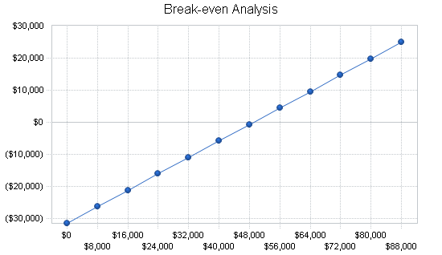

Need actual charts?
We recommend using Business Plan Pro as the easiest way to create graphs for your own business plan.
Edit this sample plan »
Break-even Analysis
Monthly Revenue Break-even | $49,013
Assumptions:
Average Percent Variable Cost | 36%
Estimated Monthly Fixed Cost | $31,400

Projected Profit and Loss
The following table and charts will highlight projected profit and loss for the next three years.

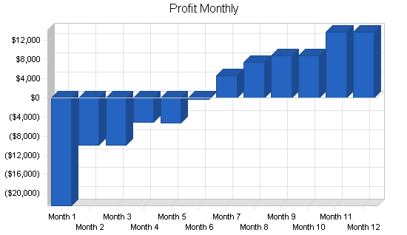

Need actual charts?
We recommend using Business Plan Pro as the easiest way to create graphs for your own business plan.
Edit this sample plan »

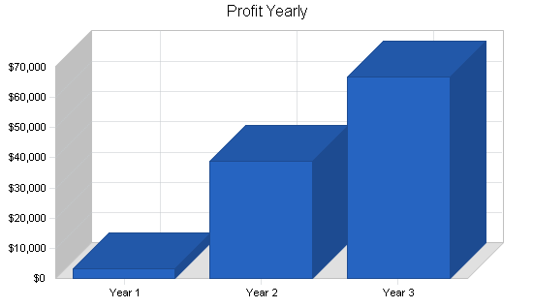

Need actual charts?
We recommend using Business Plan Pro as the easiest way to create graphs for your own business plan.
Edit this sample plan »

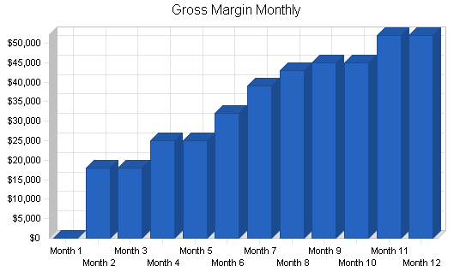

Need actual charts?
We recommend using Business Plan Pro as the easiest way to create graphs for your own business plan.
Edit this sample plan »

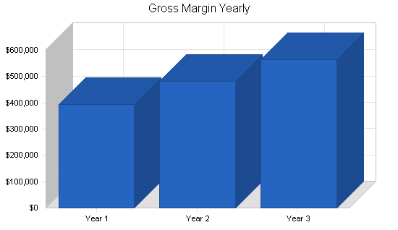

Need actual charts?
We recommend using Business Plan Pro as the easiest way to create graphs for your own business plan.
Edit this sample plan »
Pro Forma Profit and Loss
 | Year 1 | Year 2 | Year 3
Sales | $615,000 | $750,000 | $880,000
Direct Cost of Sales | $221,000 | $269,250 | $315,920
Other Production Expenses | $0 | $0 | $0
Total Cost of Sales | $221,000 | $269,250 | $315,920
Gross Margin | $394,000 | $480,750 | $564,080
Gross Margin % | 64.07% | 64.10% | 64.10%
Expenses
Payroll | $264,000 | $290,000 | $324,000
Sales and Marketing and Other Expenses | $24,000 | $30,000 | $35,000
Depreciation | $12,000 | $12,000 | $12,000
Leased Equipment | $0 | $0 | $0
Utilities | $6,000 | $6,000 | $6,000
Insurance | $7,200 | $7,200 | $7,200
Rent | $24,000 | $24,000 | $24,000
Payroll Taxes | $39,600 | $43,500 | $48,600
Other | $0 | $0 | $0
Total Operating Expenses | $376,800 | $412,700 | $456,800
Profit Before Interest and Taxes | $17,200 | $68,050 | $107,280
EBITDA | $29,200 | $80,050 | $119,280
Interest Expense | $12,463 | $12,520 | $11,777
Taxes Incurred | $1,421 | $16,659 | $28,651
Net Profit | $3,316 | $38,871 | $66,852
Net Profit/Sales | 0.54% | 5.18% | 7.60%

Projected Cash Flow
The following table and chart highlight the projected cash flow for three years. It will be necessary for each Wright brother to loan the company additional funds mid-year.

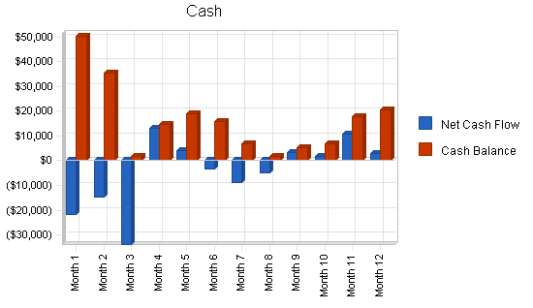

Need actual charts?
We recommend using Business Plan Pro as the easiest way to create graphs for your own business plan.
Edit this sample plan »
Pro Forma Cash Flow
 | Year 1 | Year 2 | Year 3
Cash Received
Cash from Operations
Cash Sales | $153,750 | $187,500 | $220,000
Cash from Receivables | $343,250 | $536,598 | $635,057
Subtotal Cash from Operations | $497,000 | $724,098 | $855,057
Additional Cash Received
Sales Tax, VAT, HST/GST Received | $0 | $0 | $0
New Current Borrowing | $0 | $0 | $0
New Other Liabilities (interest-free) | $0 | $0 | $0
New Long-term Liabilities | $40,000 | $0 | $0
Sales of Other Current Assets | $0 | $0 | $0
Sales of Long-term Assets | $0 | $0 | $0
New Investment Received | $0 | $0 | $0
Subtotal Cash Received | $537,000 | $724,098 | $855,057
Expenditures | Year 1 | Year 2 | Year 3
Expenditures from Operations
Cash Spending | $264,000 | $290,000 | $324,000
Bill Payments | $314,168 | $418,284 | $475,335
Subtotal Spent on Operations | $578,168 | $708,284 | $799,335
Additional Cash Spent
Sales Tax, VAT, HST/GST Paid Out | $0 | $0 | $0
Principal Repayment of Current Borrowing | $0 | $0 | $0
Other Liabilities Principal Repayment | $0 | $0 | $0
Long-term Liabilities Principal Repayment | $9,864 | $9,864 | $5,000
Purchase Other Current Assets | $0 | $0 | $0
Purchase Long-term Assets | $0 | $0 | $0
Dividends | $0 | $0 | $0
Subtotal Cash Spent | $588,032 | $718,148 | $804,335
Net Cash Flow | ($51,032) | $5,950 | $50,722
Cash Balance | $20,668 | $26,618 | $77,340

Projected Balance Sheet
The following table highlights the projected balance sheet for three years.
Pro Forma Balance Sheet
 | Year 1 | Year 2 | Year 3
Assets
Current Assets
Cash | $20,668 | $26,618 | $77,340
Accounts Receivable | $118,000 | $143,902 | $168,846
Inventory | $30,800 | $31,307 | $35,377
Other Current Assets | $12,000 | $12,000 | $12,000
Total Current Assets | $181,468 | $213,827 | $293,562
Long-term Assets
Long-term Assets | $80,000 | $80,000 | $80,000
Accumulated Depreciation | $12,000 | $24,000 | $36,000
Total Long-term Assets | $68,000 | $56,000 | $44,000
Total Assets | $249,468 | $269,827 | $337,562
Liabilities and Capital | Year 1 | Year 2 | Year 3
Current Liabilities
Accounts Payable | $42,317 | $33,669 | $39,552
Current Borrowing | $0 | $0 | $0
Other Current Liabilities | $0 | $0 | $0
Subtotal Current Liabilities | $42,317 | $33,669 | $39,552
Long-term Liabilities | $130,136 | $120,272 | $115,272
Total Liabilities | $172,453 | $153,941 | $154,824
Paid-in Capital | $150,000 | $150,000 | $150,000
Retained Earnings | ($76,300) | ($72,984) | ($34,114)
Earnings | $3,316 | $38,871 | $66,852
Total Capital | $77,016 | $115,886 | $182,738
Total Liabilities and Capital | $249,468 | $269,827 | $337,562
Net Worth | $77,016 | $115,886 | $182,738

Need real financials?
We recommend using Business Plan Pro as the easiest way to create automatic financials for your own business plan.
Edit this sample plan »

Business Ratios
Business ratios for the years of this plan are shown below. Industry profile ratios based on the Standard Industrial Classification (SIC) code 8072, Dental Laboratories, are shown for comparison.
Read more: http://www.bplans.com/dental_laboratories_business_plan/financial_plan_fc.php#ixzz1RnLw65Js

